Project Design Phase-II Technology Stack (Architecture & Stack)

Date | 01-02-2026
Team ID | LTVIP2026TMIDS24918
Project Name | Visualizing Housing Market Trends: An Analysis of  Sale Prices and Features using Tableau
Maximum Marks | 4 Marks

Technical Architecture:
The Deliverable include’s the architectural diagram as below and the information as per the table1 & table 2
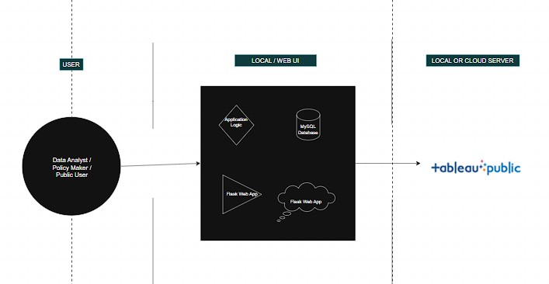

Table-1 : Components & Technologies :

S.No | Component | Description | Technology
1 | User Interface | Web interface to interact with dashboard | HTML, CSS, JavaScript, Flask
2 | Application Logic-1 | Data preprocessing and transformation | Python (Pandas, NumPy)
3 | Application Logic-2 | Connecting database with Tableau | MySQL Connector, SQLAlchemy
4 | Application Logic-3 | Dashboard and Story creation using visualizations | Tableau Desktop / Tableau Public
5 | Database | visualizing house market dataset | MySQL
6 | Cloud Database | Optional cloud hosting for shared access | AWS RDS or Google Cloud SQL
7 | File Storage | Store raw datasets and exports | Local Filesystem / Google Drive
8 | External API-1 | Embedding Tableau Public dashboard | Tableau Public Share/Embed API
9 | External API-2 | Not applicable for this project | —
10 | Machine Learning Model | (Optional) Forecasting electricity usage | Prophet (by Facebook), Scikit-learn
11 | Infrastructure | Hosting the Flask web app and dashboard | Localhost / PythonAnywhere / Heroku

Table-2: Application Characteristics:

S.No | Characteristics | Description | Technology
1 | Open-Source Frameworks | Python, Flask, Pandas, MySQL, Tableau Public | Flask, Pandas, MySQL
2 | Security Implementations | Dashboard visibility control via Tableau Public, secure file storage | Tableau Public sharing settings, Flask routes
3 | Scalable Architecture | Modular design; easy to add new visualizations and filters | 2-Tier Architecture (Frontend + Backend)
4 | Availability | Can be deployed on cloud platforms for 24/7 availability | Heroku, AWS, PythonAnywhere
5 | Performance | Pre-processed data in MySQL; responsive filters in Tableau | SQL indexing, Filter optimization

